
Sri Lanka Institute of Information Technology

IT3012 : Intelligent Agents - Lab 4
Y3.S1.WD.AI.01.01
Malabe Campus

Student ID - | IT24100140
Student Name - | Prathiban HTP
Module Name - | Intelligent Agents
Module Number - | IT3012
LabSheet Number - | 4
LabSheet Date - | 2026/Aug/17

Task 1
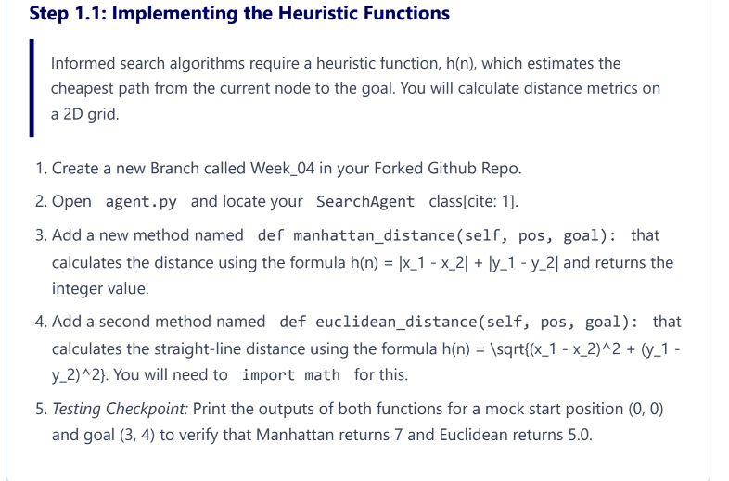
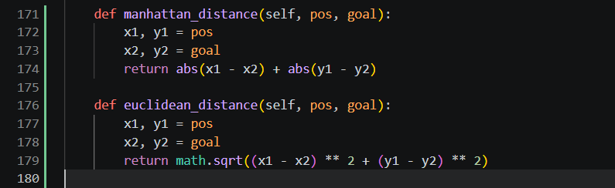
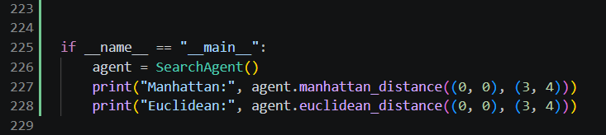

Task 2
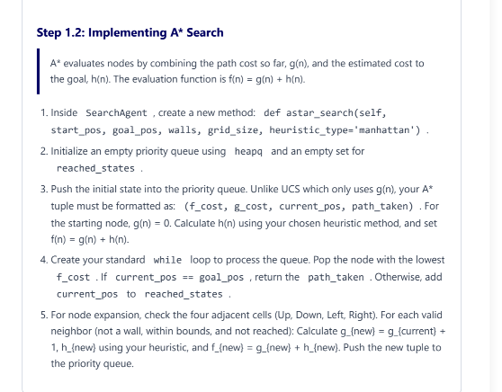
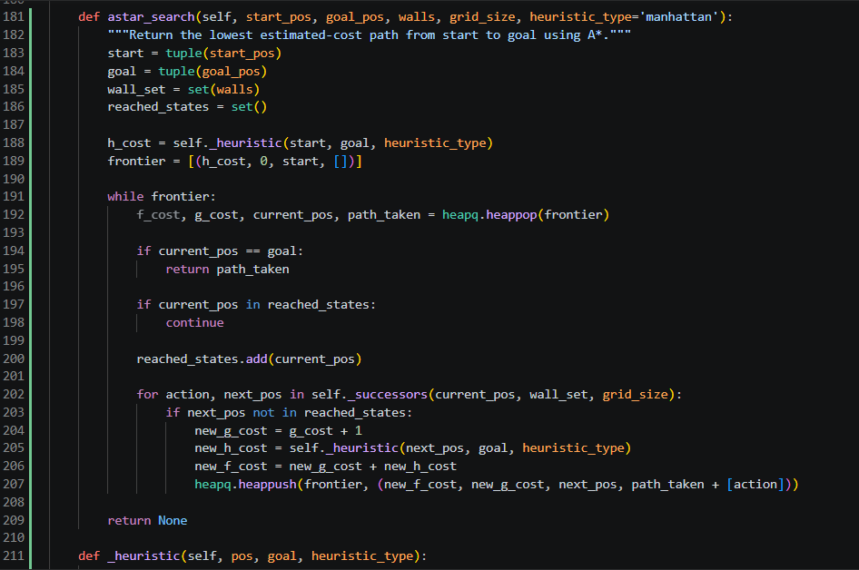

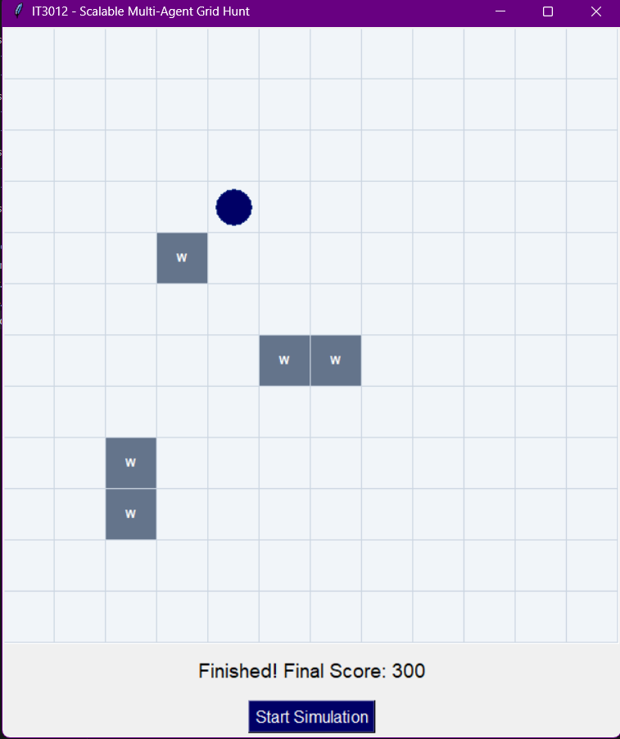

Task 3
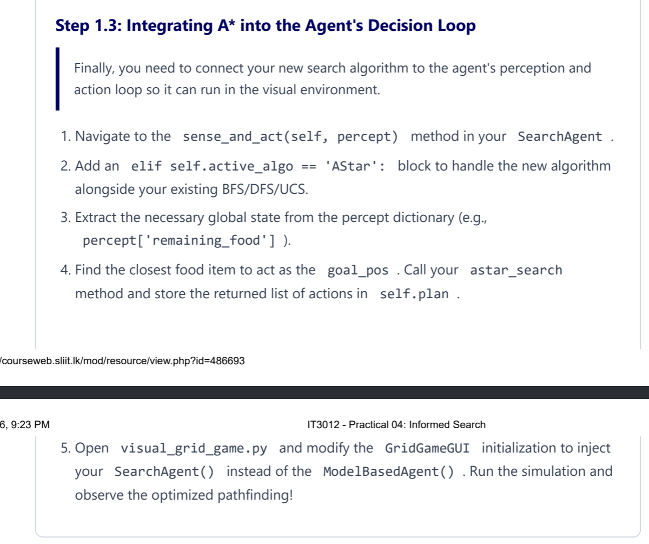
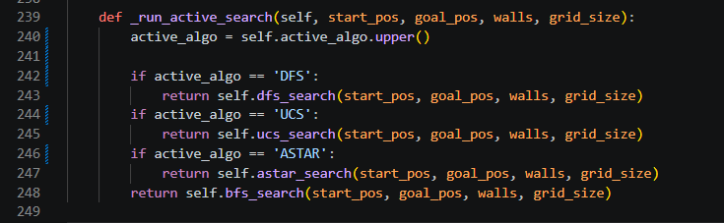
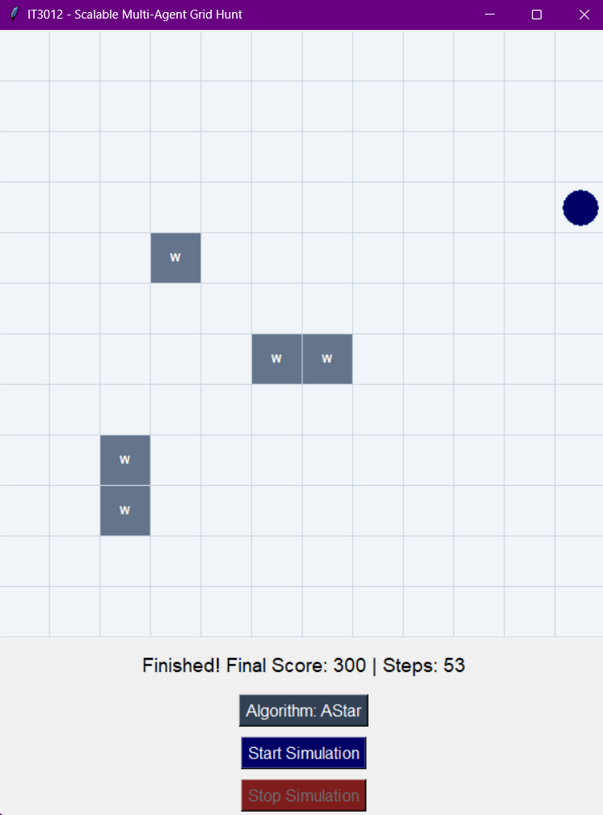

Theoretical Evaluation
1.
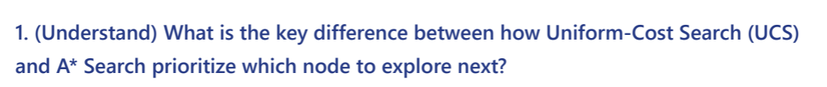
Uniform-Cost Search selects the node with the lowest path cost from the start, which is represented by g(n). A* Search selects the node using f(n) = g(n) + h(n), where g(n) is the cost already travelled and h(n) is the estimated cost from the current node to the goal. Therefore, the main difference is that UCS only considers the cost travelled so far, while A* also considers an estimate of the remaining distance.
2.
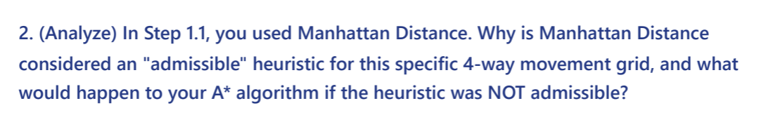
Manhattan Distance is admissible in a 4-way grid because the agent can only move up, down, left, or right, so the heuristic does not overestimate the minimum number of moves needed to reach the goal. If a heuristic is not admissible and overestimates the actual remaining cost, A* may choose a non-optimal path and therefore lose its guarantee of finding the best solution.

3.
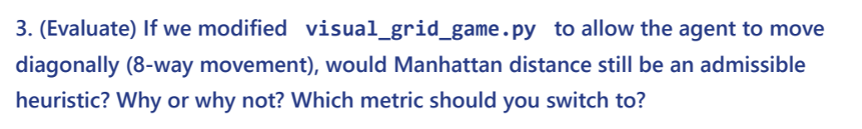
Manhattan Distance is not suitable when diagonal movement is allowed because it can overestimate the actual shortest path. For example, moving from (0,0) to (3,3) has a Manhattan Distance of 6, but with diagonal movement the goal can be reached in only 3 moves. In this case, a heuristic such as Chebyshev Distance is more suitable when straight and diagonal moves have the same cost
4.
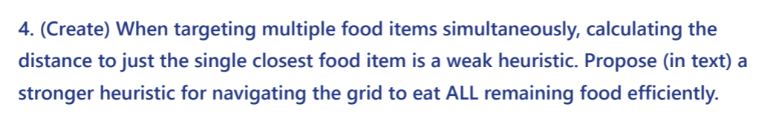
For a problem with multiple food items, a stronger heuristic should estimate the cost of collecting all remaining food instead of considering only the nearest food item. One useful approach is to calculate the distance from the agent to the nearest food and combine it with the estimated minimum cost of connecting all remaining food locations, such as using a Minimum Spanning Tree (MST). This gives A* a better estimate of the total remaining cost and can reduce unnecessary node exploration.

